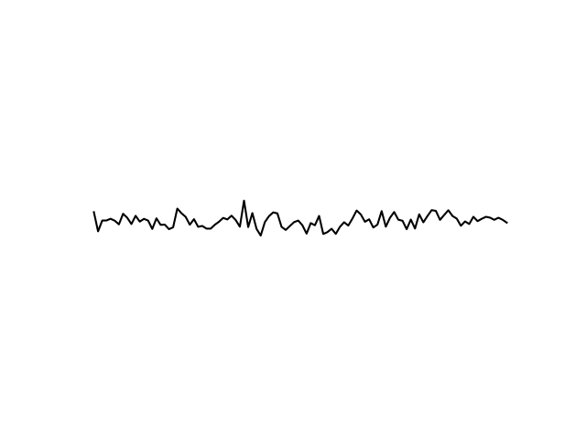
Antenna

Wide range of frequencies.
High level of noise
voltage
time
Frequency

power

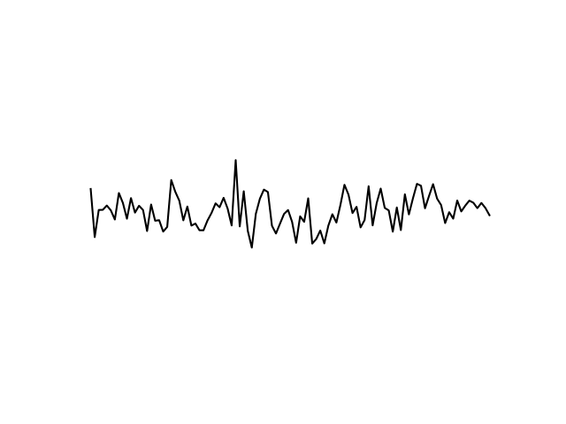

Pre-amplifier

Signal is amplified.
Little extra noise is added
frequency
power
Amplifier

Signal is again amplified with a linear phase response.

Mixer
RF frequencies are down-converted to lower a band.
power
time
Frequency
time
voltage
power
frequency
time
Frequency
voltage
voltage
power
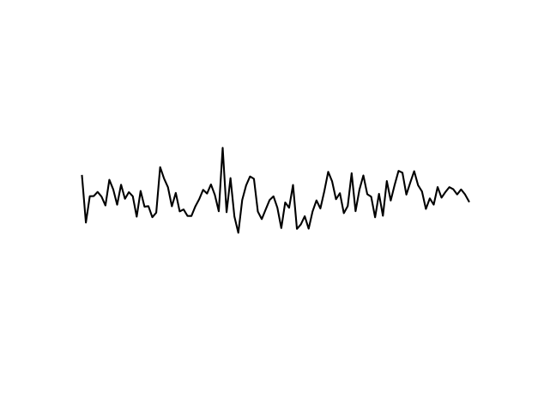
Band-pass filter

Only a smaller range of frequencies are permitted
With curved corners
Square-law detector

Signal gets converted to DC, the average voltage value being its power
Integrator

Standard deviation of the voltage is reduced improving SNR.
time
voltage
Frequency
power
power
Frequency
power
time
Frequency
power
time
power
power
Frequency

